
2024-2025 Weekly Lesson Planning Document
Template for the following:
Science, Social Studies, CTE, World Languages,
HPELW, Fine Arts, JROTC
Week of Monday, January 6, through Friday, January 10

EDUCATOR’S NAME: ___ Ms. Burton, Ms. Daughrity, Ms. Mitchell ____________________________________ SUBJECT: ______Chemistry I______________________________________
 | MONDAY | TUESDAY | WEDNESDAY |  | THURSDAY | FRIDAY
Lesson Title:  Unit:  Chapter:  Page Number(s):  (It is suggested that you use your curriculum map.) | Unit 5  Chapter 2:  Measurements & Calculations  pp. 50-54 | Unit 5  Chapter 2:  Measurements & Calculations  pp. 50-54 |  | Unit 5  Chapter 2:  Measurements & Calculations  pp. 50-54 | Unit 5  Chapter 2:  Measurements & Calculations  pp. 50-54 |  | Unit 5  Chapter 2:  Measurements & Calculations  pp. 50-54
TN Standard(s):  Grade level standard (include standard notation and language).  Which State Standard is your lesson addressing? This should also be on your Whiteboard Protocol. | CHEM1.PS1.1 Understand and be prepared to use values specific to chemical processes: the mole, molar mass, molarity, and percent composition.

Objective (s):  What specifically should students be able to do at the end of the lesson? The objective is standards-based.  Write the objective in student friendly terms. For example, I can multiply binomials.  This is should also be on your Whiteboard Protocol.  What do you want students to know, understand and be able to do as a result of this lesson?  The objective should be written using the stem…  I CAN…. | I Can…  Recall concepts concerning counting significant figures, rounding to specified numbers of significant figures, and multiplying and dividing using correct significant figures. |  | I Can…  Convert between units using dimensional analysis in order to calculate measurements without using measuring tools. |  | I Can…  Convert between units using dimensional analysis in order to calculate measurements without using measuring tools. |  | I Can…  Convert between units using dimensional analysis in order to calculate measurements without using measuring tools. |  | I Can…  Recall and apply all previous knowledge from Chapter 2 in order to show mastery of Measurements and Calculations concepts on the Dimensional Analysis quiz.
Possible Misconception (s):  What misconception(s) are you anticipating during this lesson? | Draw models of cubes on the board or display some three-dimensional models of cubes to help students with spatial relationships. Students often make errors in comparing related cubic units. For example, students know that there are 1000 mm in 1 m. They may then incorrectly assume that there are 1000 mm³ (103 mm³) in 1 m³ instead of the 109 mm³ that are actually present (103 mm × 103 mm × 103 mm = 109 mm³). Draw a model for this cube so students can see why a cube with lengths of 1000 mm per side has a volume of 1 × 109 mm³. Both the numerical value and the unit must be cubed.  The term precision is often misunderstood as meaning the same thing as accuracy. Make sure students understand what precision is, and take time to reinforce the concept throughout the course.  Students typically have difficulty in rounding numbers that are exactly halfway between two numbers. Use examples to show that these numbers are rounded to the nearest even number. Students may also be confused in rounding numbers that contain a 5 but to which the odd/even rule does not apply. For example, the number 1.651 rounded to two digits is 1.7, not 1.6; the fact that 6 is even is irrelevant, given that the number is closer to 1.7 than it is to 1.6.
Literacy-Based DO NOW:  This literacy-based activity should be ready for students to begin working on upon entering class. Students should have an opportunity to read, write, and/or speak. | New Year…New You! Identify one way to improve your performance in Chemistry as we begin 2nd Semester. | A block of sodium has measurements of 3.00 cm x 5.00 cm x 5.00 cm and a mass of 75.50 g. Calculate the density of the sodium using correct sig figs and units. |  | Identify the information that goes into the quadrants of a “t-chart.”  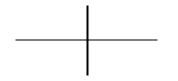 |  | The distance between Memphis and Nashville is approximately 205 miles. How many kilometers would that be if 1 km = 0.621 mile? Show all work & use correct sig figs and units! |  | Prepare for your Dimensional Analysis quiz.
Agenda for the Day  Simple outline of lesson segments or activities that is time stamped.  Teacher/class should take 2 minutes or less to review. | - Do Now (8 minutes)  - Review Learning Objective (2 minutes)  - I Do (12 minutes)  - We Do (12 minutes)  - You Do (13 minutes)  - Exit Ticket (5 minutes) | - Do Now (8 minutes)  - Review Learning Objective (2 minutes)  - I Do (12 minutes)  - We Do (12 minutes)  - You Do (13 minutes)  - Exit Ticket (5 minutes) |  | - Do Now (8 minutes)  - Review Learning Objective (2 minutes)  - I Do (12 minutes)  - We Do (12 minutes)  - You Do (13 minutes)  - Exit Ticket (5 minutes) |  | - Do Now (8 minutes)  - Review Learning Objective (2 minutes)  - I Do (12 minutes)  - We Do (12 minutes)  - You Do (13 minutes)  - Exit Ticket (5 minutes) |  | - Do Now (8 minutes)  - Quiz (84 minutes)
Beginning of Lesson  I Do  Science: Engage & Explore | I will provide students with a review assignment to practice counting sig figs, rounding value to a specified number of sig figs, and multiplying and dividing using correct sig figs. | I will introduce the concept of dimensional analysis. |  | I will provide an assignment to allow students to practice solving dimensional analysis problems. |  | I will provide an assignment to allow students to practice solving dimensional analysis problems. |  | I will distribute the Dimensional Analysis quiz to the class.
Middle of the lesson  We Do  Science: Explain and Elaborate | Work in small groups to answer questions concerning counting sig figs, rounding value to a specified number of sig figs, and multiplying and dividing using correct sig figs. | Respond to CFUs embedded in the guided notes to indicate mastery of the concepts covered in class today. |  | Respond to CFUs embedded in the guided notes to indicate mastery of the concepts covered in class today. |  | Respond to CFUs embedded in the guided notes to indicate mastery of the concepts covered in class today.
End of the lesson  You Do  Science: Evaluate | Complete the review assignment about counting sig figs, rounding value to a specified number of sig figs, and multiplying and dividing using correct sig figs.  Ask any questions I have concerning these concepts. | Respond to CFUs embedded in the guided notes to indicate mastery of the concepts covered in class today.  Ask any questions I have concerning dimensional analysis. |  | Respond to CFUs embedded in the guided notes to indicate mastery of the concepts covered in class today.  Begin the dimensional analysis assignment. |  | Respond to CFUs embedded in the guided notes to indicate mastery of the concepts covered in class today.  Complete the dimensional analysis assignment. |  | Complete the Dimensional Analysis quiz.
(05 MINUTES MAX)  Literacy Based closing activity:  Engage students in reading and writing tasks that assess their understanding of the lesson. Students are drawn back to the objective for the day. | Complete literacy-based Exit Ticket question on paper or in Microsoft Forums. Will be based on what was discussed in lesson for the day. | Complete literacy-based Exit Ticket question on paper or in Microsoft Forums. Will be based on what was discussed in lesson for the day. |  | Complete literacy-based Exit Ticket question on paper or in Microsoft Forums. Will be based on what was discussed in lesson for the day. |  | Complete literacy-based Exit Ticket question on paper or in Microsoft Forums. Will be based on what was discussed in lesson for the day. |  | Complete literacy-based Exit Ticket question on paper or in Microsoft Forums. Will be based on what was discussed in lesson for the day.
SPED Modification (s):  What modifications are being made to accommodate the students receiving special services? | Extended time on assignments; ability to correct assignments; reduced number of problems  Planned/preferential seating  Allow breaks during class  Extended time for testing; reduced choices on multiple choice tests  Repeating directions verbatim
ESL Modification (s):  What modifications are being made to accommodate the students receiving special services? | Small group instruction  Read aloud for assessments  Interactive reader for computer assignments  Extended time on assignments and tests  Opportunity to redo assignments and correct tests based on teacher feedback  Bilingual support provided by translated copies, peers, and dictionaries
Assessment (s):  How will you know that students have reached the objective?  Assessments may include:  Pre-assessment, formative assessments, summative assessment, post-assessment, discussions, performance, demonstration, etc. | Formative assessment of the students have related to the concepts in the Semester Exam review packet. |  | Formative assessment of the answers to the Semester 1 review questions. |  | Summative assessment in responses to the Semester 1 Exam questions. |  | Summative assessment in responses to the Semester 1 Exam questions. |  | Summative assessment in responses to the Semester 1 Exam questions.
Corrective Activity (s):  What will I do if the student doesn’t understand the lesson? | -Weekly tutoring sessions  -Peer tutoring partners.  -Opportunity for corrections. |  | -Weekly tutoring sessions  -Peer tutoring partners.  -Opportunity for corrections. |  | -Weekly tutoring sessions  -Peer tutoring partners.  -Opportunity for corrections. |  | -Weekly tutoring sessions  -Peer tutoring partners.  -Opportunity for corrections. |  | -Weekly tutoring sessions  -Peer tutoring partners.  -Opportunity for test corrections.
Extension/Enrichment Activity (s):  What will I do with students who understand quicker than others? | - Have each student imagine that he or she, along with other passengers, has become shipwrecked on an island. With no chance of rescue, the castaways decide to start a new country and elect him or her president. One of the first tasks of the president is to divide up the land among the people in a way that is fair to all. But the president realizes he or she has nothing to use for taking measurements and so has to come up with a new measuring system. On a sheet of paper, have students answer the following questions: 1) What will you call your unit of measurement? 2) Why would it be important to use a consistent standard of measurement? 3) What factors would be important as a basis for your measurement?  - Have students select five liquids from Figure 2.8. Ask them to imagine that the five liquids are mixed in a large container and then poured into a graduated cylinder, such as the one shown in Figure 2.7. Have students predict what will happen as time passes  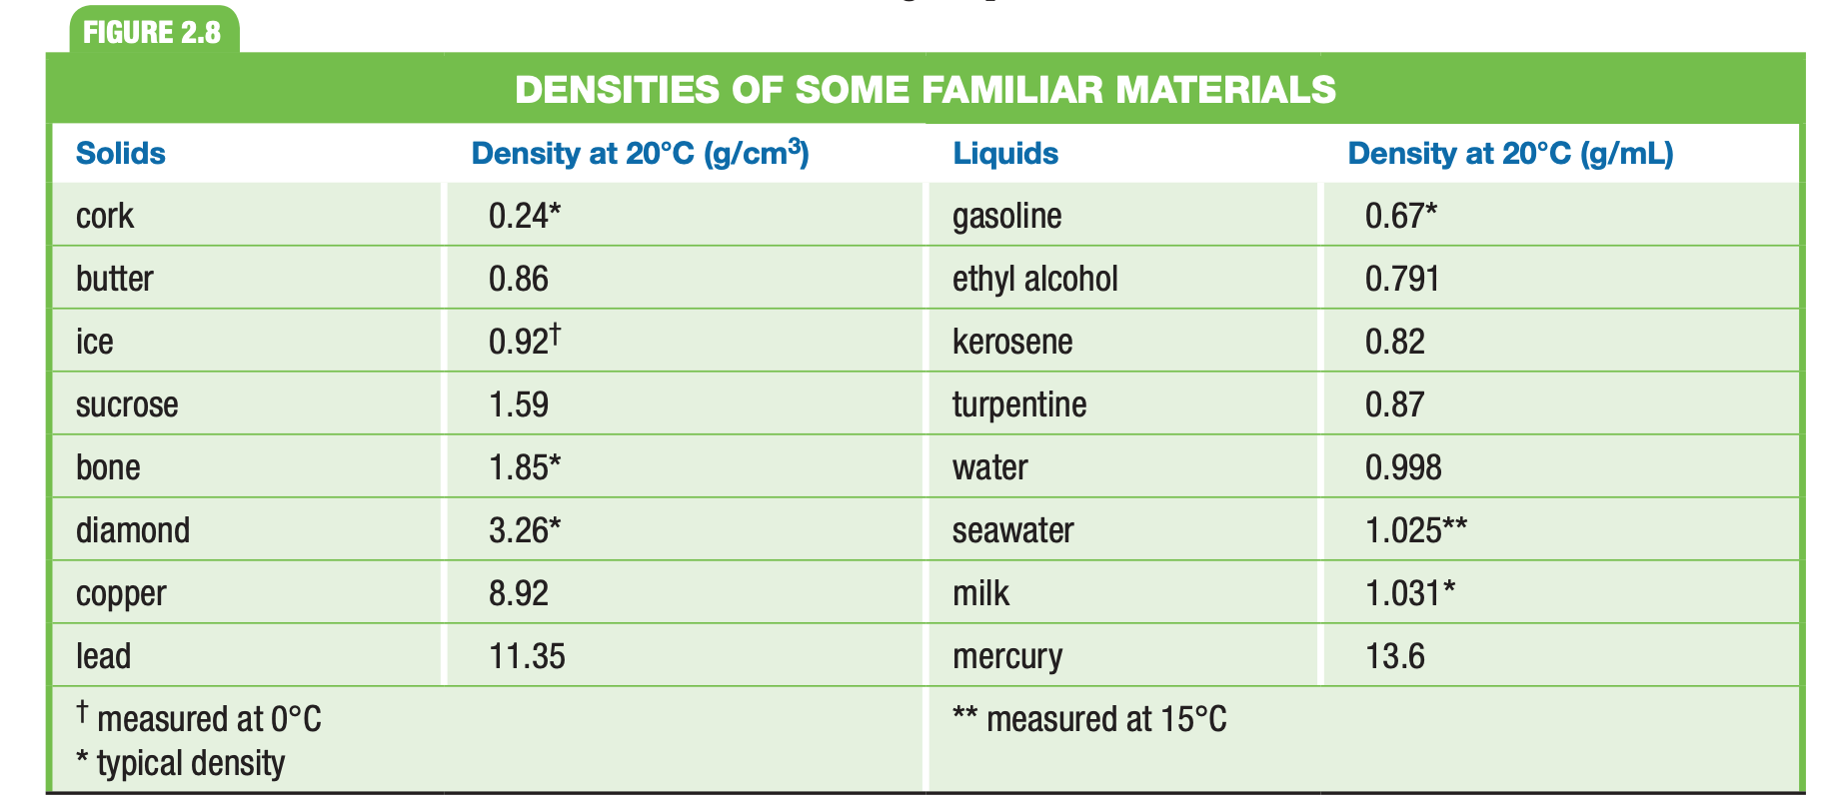
Technology Integration:  How will the students use technology to help them master the objective. | - Use district-issued electronic device to complete online assignments, formative assessments (exit tickets), and summative assessments.

IN THE FOLLOWING PAGES:
ONLY COMPLETE SECTION(S) BELOW IF YOUR SUBJECT IS IDENTIFIED/LISTED
ALL SCIENCE (S):  What is your resource plan for each of the 5 Es of inquiry-based science instruction?  - Engage  - Explore  - Explain  - Elaborate  - Evaluate | Engage  - Ch. 2 Section 2 Classroom Catalyst, TE p. 37  - Ch. 2 Section 3 Classroom Catalyst, TE p. 48  - Differentiated Instruction TE pp. 38-42; 48; 52; 57; 59-60.  Interactive Video  - Chapter 2: Why It Matters: Measurements and Calculations  https://my.hrw.com/content/hmof/science/hss2017/tn/gr9-12/hmd_chem_9781328833594_/dlo/whyitmatters/index.html?vid=1  Explore  Laboratory Activities/Investigations/Animations & Simulations  - Virtual Lab: Using Units and Measurements  https://my.hrw.com/content/hmof/science/hss2017/tn/gr9-12/hmd_chem_9781328833594_/dlo/virtuallab/c02_00vl16/index.html  - PhET Simulation: “Density”  http://phet.colorado.edu/en/simulation/density  - Uncertainty in Measurements  http://antoine.frostburg.edu/cgi-bin/senese/tutorials/sigfig/index.cgi  - Precision and Accuracy  http://www.learner.org/courses/learningmath/measurement/session2/part_c/accuracy.html  - “Rags to Riches” Game (Scientific Notation and the Metric System)  http://www.quia.com/rr/83587.html  Explain  Textbook  - Units of Measurement, pp. 37-46  - Using Scientific Measurements, pp. 48-61  - Interactive Reader: Section 2.2 and 2.3  Elaborate  - Cross-Disciplinary Connection: Classical Ideas About Matter (SE)  (HRW RESOURCE)  - Differentiated Instruction (TE wrap) (HRW RESOURCE)  - WebLinks (HRW RESOURCE)  Evaluate  - Ch. 2 Section 2 Formative Assessment, TE/SE p. 46  - Ch. 2 Section 3 Formative Assessment, TE/SE p. 61
ALL SCIENCE (S):  (Multiple opportunities to engage in science, Makes since of science content)  What is your plan to incorporate technology while incorporating the 5E instructional model? | SUGGESTED OPPORTUNITIES FOR TECHNOLOGY  1. PhET Simulations  2. Microsoft Forms  3. Virtual Lab

